PROJECT Αρχές γλωσσών και μεταφραστών

1) Tα παρακάτω είναι ο bnf συντακτικός ορισμός της γραμματικής της γλώσσας.

atom ::=

identifier | literal | enclosure

enclosure ::=

parenth_form | list_display

| generator_expression | dict_display

| string_conversion | yield_atom

literal ::=

stringliteral | integer | longinteger

| floatnumber | imagnumber

stringliteral ::=

stringliteralpiece

| stringliteral stringliteralpiece

parenth_form ::=

"(" [expression_list] ")"

list_display ::=

"[" [expression_list | list_comprehension] "]"

list_comprehension ::=

expression list_for

list_for ::=

"for" target_list "in" old_expression_list

[list_iter]

old_expression_list ::=

old_expression

[("," old_expression)+ [","]]

list_iter ::=

list_for | list_if

list_if ::=

"if" old_expression [list_iter]

generator_expression ::=

"(" expression genexpr_for ")"

genexpr_for ::=

"for" target_list "in" or_test

[genexpr_iter]

genexpr_iter ::=

genexpr_for | genexpr_if

genexpr_if ::=

"if" old_expression [genexpr_iter]

dict_display ::=

"{" [key_datum_list] "}"

key_datum_list ::=

key_datum ("," key_datum)* [","]

key_datum ::=

expression ":" expression

string_conversion ::=

"`" expression_list "`"

yield_atom ::=

"(" yield_expression ")"

yield_expression ::=

"yield" [expression_list]

primary ::=

atom | attributeref

| subscription | slicing | call

attributeref ::=

primary "." identifier

subscription ::=

primary "[" expression_list "]"

slicing ::=

simple_slicing | extended_slicing

simple_slicing ::=

primary "[" short_slice "]"

extended_slicing ::=

primary "[" slice_list "]"

slice_list ::=

slice_item ("," slice_item)* [","]

slice_item ::=

expression | proper_slice | ellipsis

proper_slice ::=

short_slice | long_slice

short_slice ::=

[lower_bound] ":" [upper_bound]

long_slice ::=

short_slice ":" [stride]

lower_bound ::=

expression

upper_bound ::=

expression

stride ::=

expression

ellipsis ::=

"..."

call ::=

primary "(" [argument_list [","]

| expression genexpr_for] ")"

argument_list ::=

positional_arguments ["," keyword_arguments]

["," "*" expression]

["," "**" expression]

| keyword_arguments ["," "*" expression]

["," "**" expression]

| "*" expression ["," "**" expression]

| "**" expression

positional_arguments ::=

expression ("," expression)*

keyword_arguments ::=

keyword_item ("," keyword_item)*

keyword_item ::=

identifier "=" expression

power ::=

primary ["**" u_expr]

u_expr ::=

power | "-" u_expr

| "+" u_expr | "~" u_expr

m_expr ::=

u_expr | m_expr "*" u_expr

| m_expr "//" u_expr

| m_expr "/" u_expr

| m_expr "%" u_expr

a_expr ::=

m_expr | a_expr "+" m_expr

| a_expr "-" m_expr

shift_expr ::=

a_expr

| shift_expr ( "<<" | ">>" ) a_expr

and_expr ::=

shift_expr | and_expr "&" shift_expr

xor_expr ::=

and_expr | xor_expr "^" and_expr

or_expr ::=

xor_expr | or_expr "|" xor_expr

comparison ::=

or_expr ( comp_operator or_expr )*

comp_operator ::=

"<" | ">" | "==" | ">=" | "<=" | "<>" | "!="

| "is" ["not"] | ["not"] "in"

expression ::=

conditional_expression | lambda_form

old_expression ::=

or_test | old_lambda_form

conditional_expression ::=

or_test ["if" or_test "else" expression]

or_test ::=

and_test | or_test "or" and_test

and_test ::=

not_test | and_test "and" not_test

not_test ::=

comparison | "not" not_test

lambda_form ::=

"lambda" [parameter_list] ":" expression

old_lambda_form ::=

"lambda" [parameter_list] ":" old_expression

expression_list ::=

expression ( "," expression )* [","]

simple_stmt ::= expression_stmt

| assert_stmt

| assignment_stmt

| augmented_assignment_stmt

| pass_stmt

| del_stmt

| print_stmt

| return_stmt

| yield_stmt

| raise_stmt

| break_stmt

| continue_stmt

| import_stmt

| global_stmt

| exec_stmt

expression_stmt ::=

expression_list

assert_stmt ::=

"assert" expression ["," expression]

assignment_stmt ::=

(target_list "=")+

(expression_list | yield_expression)

target_list ::=

target ("," target)* [","]

target ::=

identifier

| "(" target_list ")"

| "[" target_list "]"

| attributeref

| subscription

| slicing

augmented_assignment_stmt ::=

target augop

(expression_list | yield_expression)

augop ::=

"+=" | "-=" | "*=" | "/=" | "//=" | "%=" | "**="

| ">>=" | "<<=" | "&=" | "^=" | "|="

pass_stmt ::=

"pass"

del_stmt ::=

"del" target_list

print_stmt ::=

"print" ( [expression ("," expression)* [","]]

| ">>" expression [("," expression)+ [","]] )

return_stmt ::=

"return" [expression_list]

yield_stmt ::=

yield_expression

raise_stmt ::=

"raise" [expression ["," expression

["," expression]]]

break_stmt ::=

"break"

continue_stmt ::=

"continue"

import_stmt ::=

"import" module ["as" name]

( "," module ["as" name] )*

| "from" relative_module "import" identifier

["as" name]

( "," identifier ["as" name] )*

| "from" relative_module "import" "("

identifier ["as" name]

( "," identifier ["as" name] )* [","] ")"

| "from" module "import" "*"

module ::=

(identifier ".")* identifier

relative_module ::=

"."* module | "."+

name ::=

identifier

global_stmt ::=

"global" identifier ("," identifier)*

exec_stmt ::=

"exec" or_expr

["in" expression ["," expression]]

compound_stmt ::=

if_stmt

| while_stmt

| for_stmt

| try_stmt

| with_stmt

| funcdef

| classdef

suite ::=

stmt_list NEWLINE

| NEWLINE INDENT statement+ DEDENT

statement ::=

stmt_list NEWLINE | compound_stmt

stmt_list ::=

simple_stmt (";" simple_stmt)* [";"]

if_stmt ::=

"if" expression ":" suite

( "elif" expression ":" suite )*

["else" ":" suite]

while_stmt ::=

"while" expression ":" suite

["else" ":" suite]

for_stmt ::=

"for" target_list "in" expression_list

":" suite

["else" ":" suite]

try_stmt ::= try1_stmt | try2_stmt

try1_stmt ::=

"try" ":" suite

("except" [expression

["," target]] ":" suite)+

["else" ":" suite]

["finally" ":" suite]

try2_stmt ::=

"try" ":" suite

"finally" ":" suite

with_stmt ::=

"with" expression ["as" target] ":" suite

funcdef ::=

[decorators] "def" funcname "(" [parameter_list] ")"

":" suite

decorators ::=

decorator+

decorator ::=

"@" dotted_name ["(" [argument_list [","]] ")"] NEWLINE

dotted_name ::=

identifier ("." identifier)*

parameter_list ::=

(defparameter ",")*

("*" identifier [, "**" identifier]

| "**" identifier

| defparameter [","] )

defparameter ::=

parameter ["=" expression]

sublist ::=

parameter ("," parameter)* [","]

parameter ::=

identifier | "(" sublist ")"

funcname ::=

identifier

classdef ::=

"class" classname [inheritance] ":"

suite

inheritance ::=

"(" [expression_list] ")"

classname ::=

identifier

file_input ::=

(NEWLINE | statement)*

interactive_input ::=

[stmt_list] NEWLINE | compound_stmt NEWLINE

eval_input ::=

expression_list NEWLINE*

input_input ::=

expression_list NEWLINE

2) Eίναι η περιγραφή του αντίστοιχου υποσυνόλου της Python σε BNF

list:

/* Nothing */

| list program

;

program: ekf

| assignment

| parameters

| function

| ifstatement

| forstatement

| callfunction

| createclass

| comment

| print

| lambda

| metablhtes

;

Το program ορίζει τις επόμενες εκφράσεις που θα χρησιμοποιηθούν

ekf:

INTNUM {;}

| FLOATNUM {;}

| ekf '+' ekf

| ekf '-' ekf

| ekf '*' ekf

| ekf '/' ekf

| '(' ekf ')' {;}

|VAR

Assignment: VAR '=' ekf

|VAR

|VAR '<' ekf

|VAR '>' ekf

|VAR '!' '=' ekf

|VAR '>' '=' ekf

|VAR '<' '=' ekf

;

Το assignment εκτελεί συγκρίσεις μεταξύ αριθμών

parameters: var

| var ',' var

;

Το parameters περνάει τις παραμέτρους στην function

function: DEF VAR '(' ')' ':'

| DEF VAR'(' parameters ')' ':'

;

H function είναι η συνάρτηση

callfunction: VAR '(' ')'

| VAR '(' parameters ')'

;

Η κλήση της συνάρτησης

ifstatement: IF assignment ':'

| ELIF assignment ':'

| ELSE ':'

;

Η if

forstatement: FOR VAR IN RANGE '(' ekf ')' ':'

;

H for

createclass: CLASS VAR ':'

| VAR'=' VAR '(' parameters ')'

;

H δημιουργία κλάσης

comment: HASHTAG {YYACCEPT;}

;

Σχόλιο

print: PRINT '('''' VAR ''' ')'

| PRINT '(' ''' VAR ''' ',' VAR ')' parameters;

Εκτύπωση

lambda: LAMBDA [parameters] ":" program

λάμδα calculus

metablhtes: INT assignment

|FLOAT assignment

;

3) Aυτό είναι το τελικό αρχείο περιγραφής της γλώσσας, το οποίο δίνεται σαν είσοδος στον parser όπου γίνεται γενικός ελέγχος της λειτουργίας τόσο της γραμματικής όσο και του συντακτικού του compiler της python.

class Person:

age = 10

float child

def greet(self):

print(Hello)

if age<10:

print(underaged)

elif age>20:

print(teenager)

else :

print(getout)

child = age/2

4)Για την αρχικοποίηση έχουμε

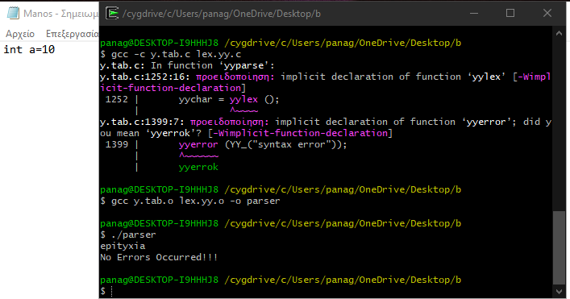

Για την κλάση έχουμε

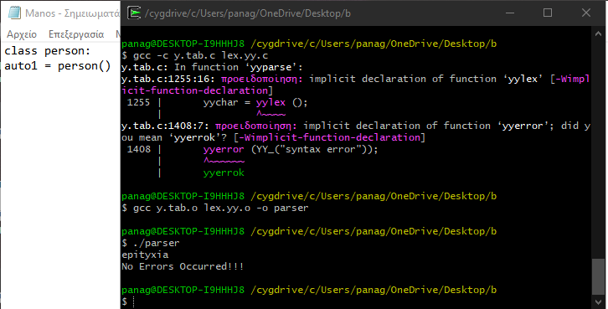

Για τον ορισμό συνάρτησης και κλήση της

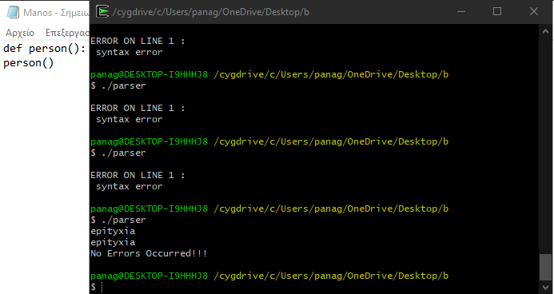

Για σχόλια

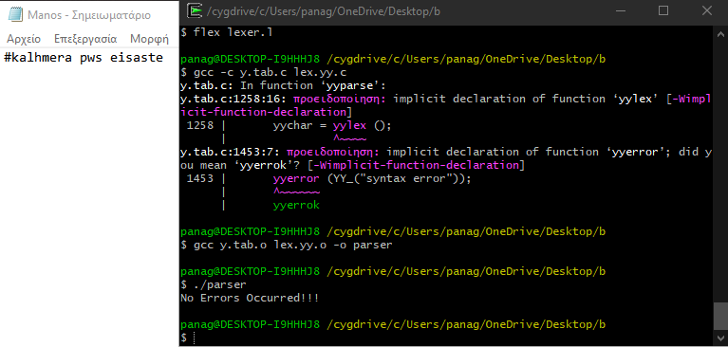

Για το if

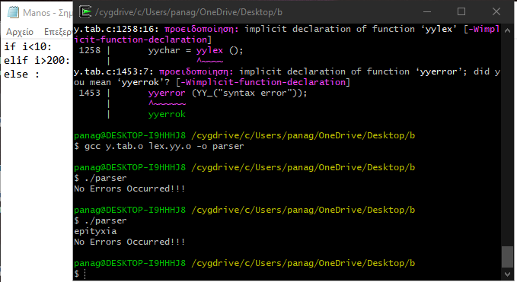

Για το for

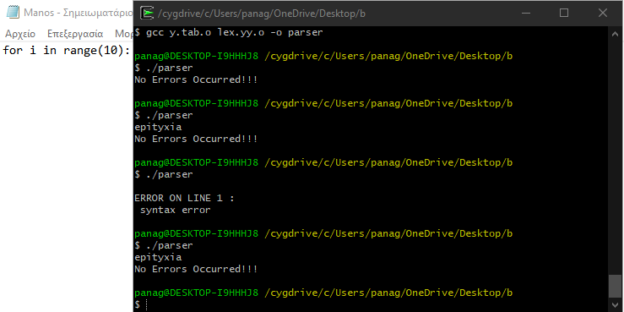

Για το print

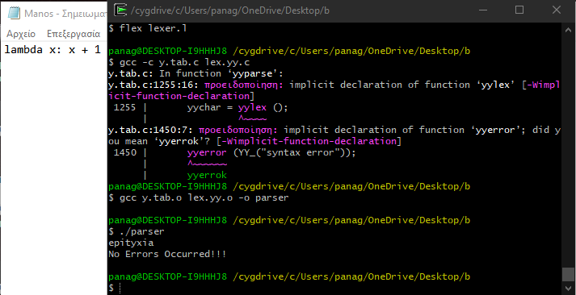

Για το lambda

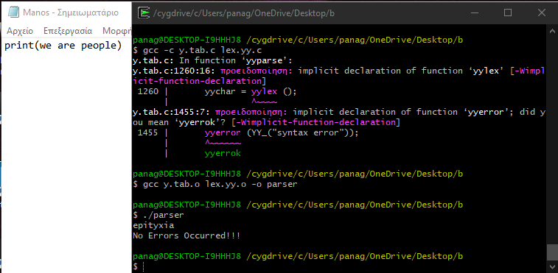

Για πράξεις

